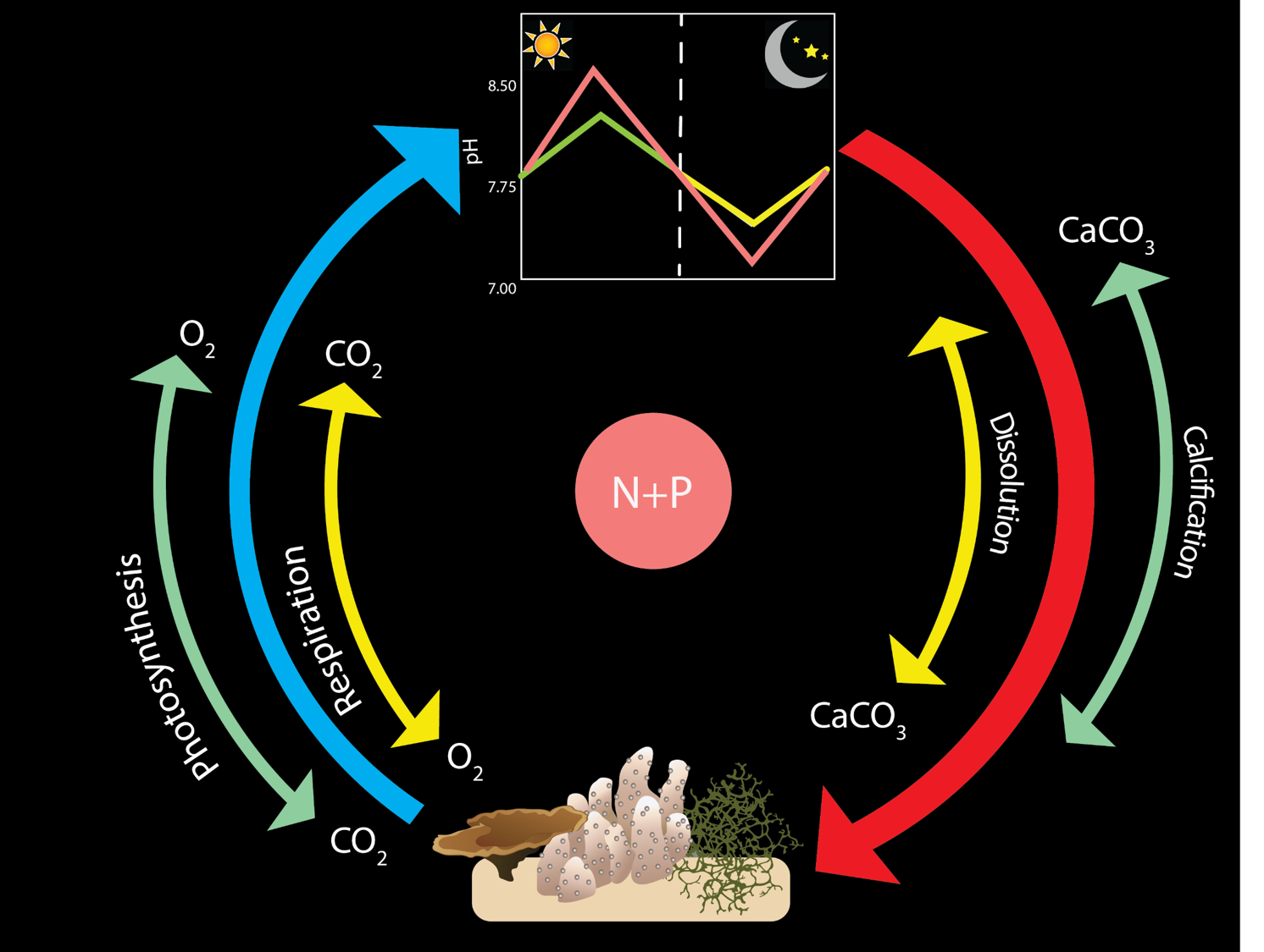

Fig 1: Illustrating feedbacks on reefs and what we predict would happen when you add nutrients…. Probably will make this a two panel figure with “typical” conditions on the left and nutrient addition conditions on the right (higher pH variable due to augmented PR cycle which impacts calcification and dissolution)